**Harmonized Unemployment Rate**

The dataset is from the [Organization for Economic Co-operation and Development (OECD)](http://www.oecd.org/) hosted by the Federal Reserve Economic Database (FRED).

**Harmonized Unemployment Rate for Australia**

* **Checked for stationarity –** Plotted the graph of the original series and of the rolling mean and standard deviation. As we can see that the mean is not constant, so the series is not stationary.

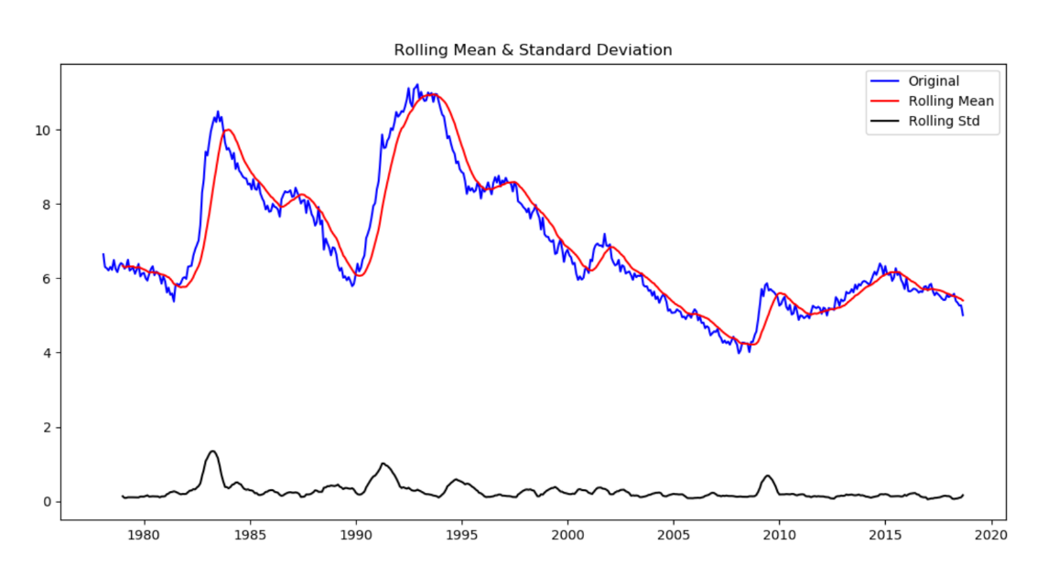

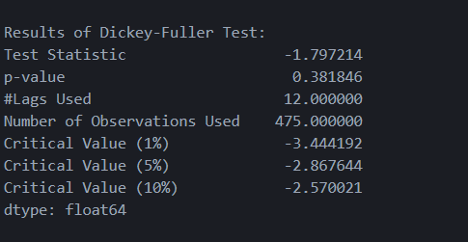

The p value from the Dickey-Fuller Test is 0.3818 so we cannot reject the null hypothesis of non-stationarity and conclude that the series is not stationary.

* **Made the Series Stationary**: There are several approaches to make the series stationary, I used difference technique to make the series stationary and observed that the series was stationary after 1 difference.

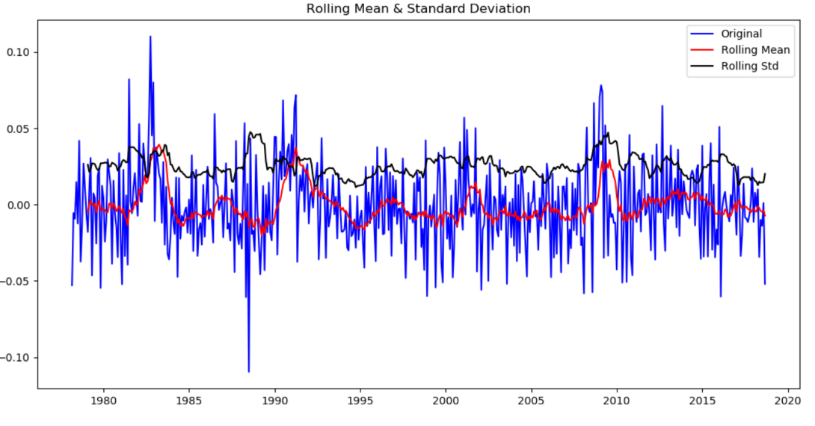

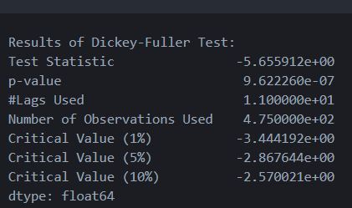

As we can see from the graph and the p value for Dickey-Fuller test we can easily say the series is stationary.

* **Checked the Number of lags to be included in the ARIMA model:**

**ACF & PACF**

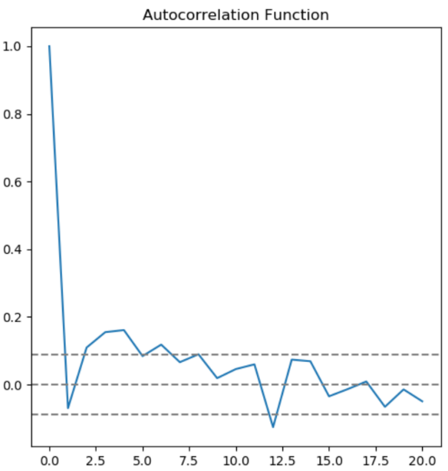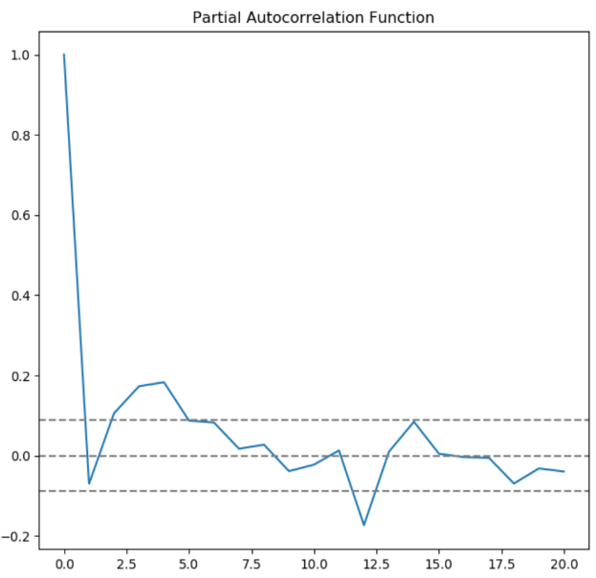

From ACF we find that the number of lags required are 5 and from PACF we get 4 lags.

* **ARIMA Models:**

**ARIMA (4,1,0)**

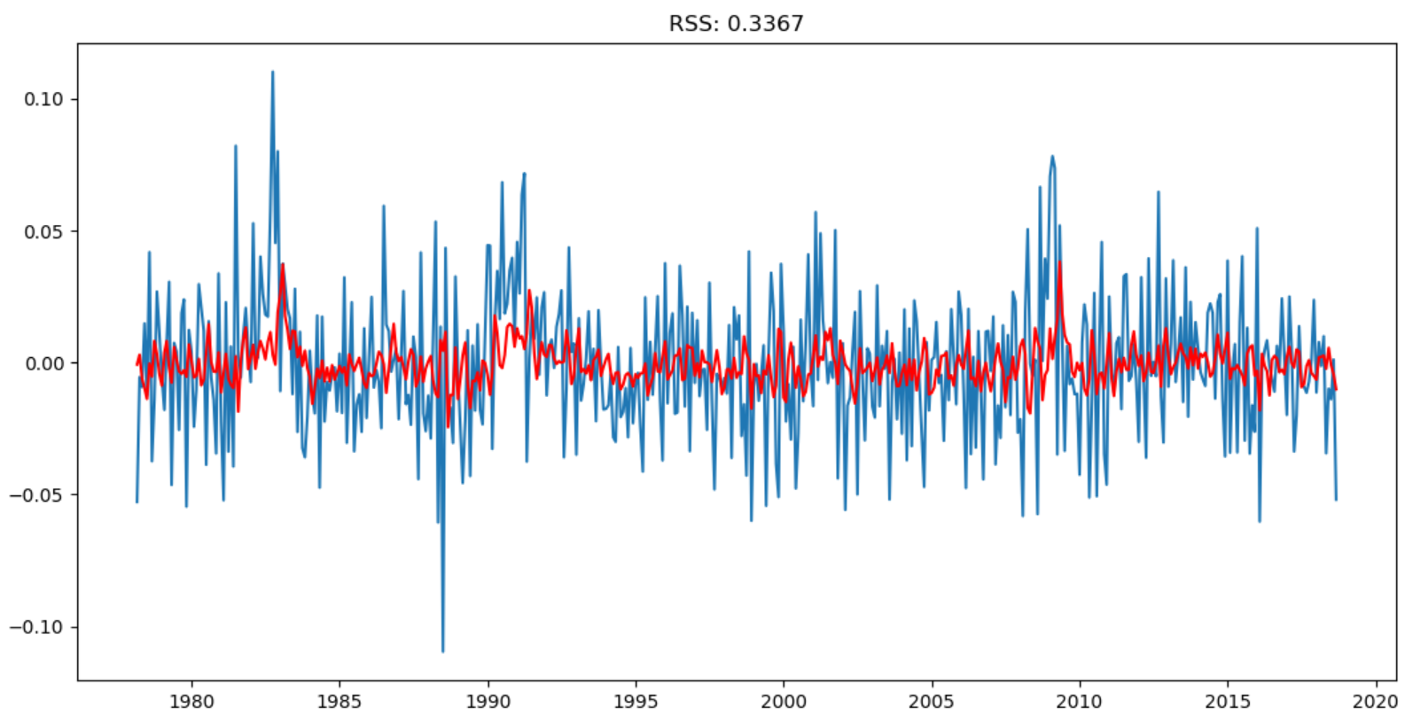

**ARIMA (0,1,5)**

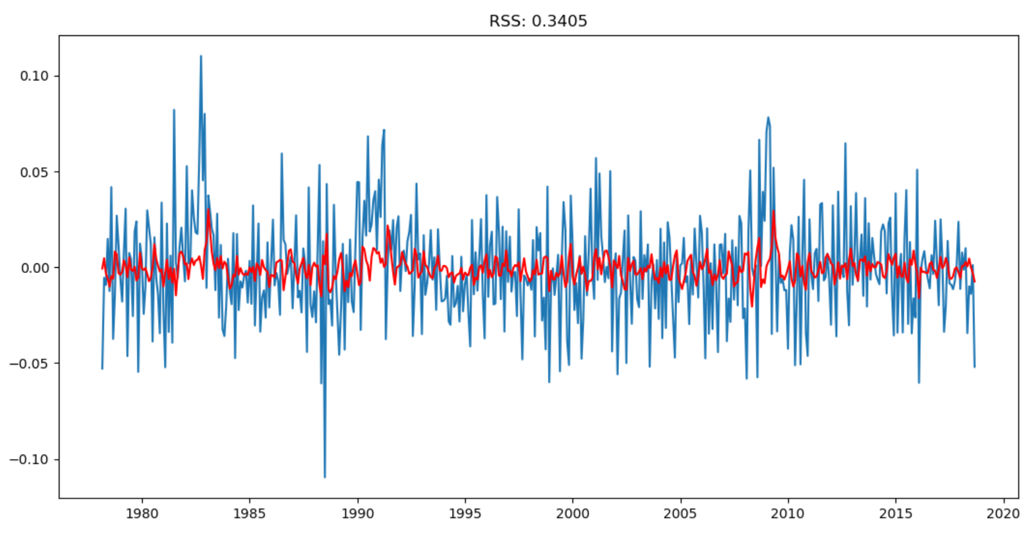

**ARIMA (4,1,5)**

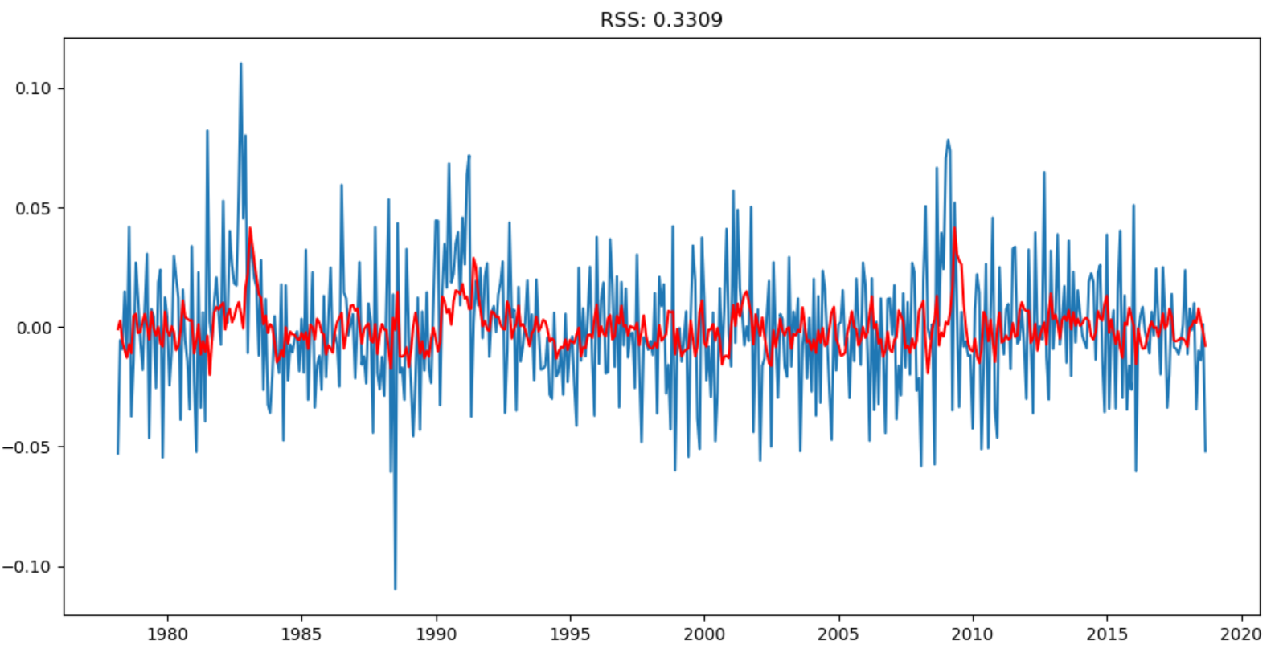

We see that model ARIMA (4,1,5) has the lowest RSS value so we will choose this model for our predictions.

* **Predictions and Accuracy**

Please find below some predicted values from the model:

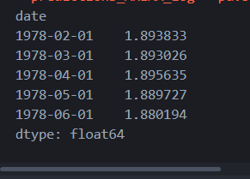

Below is the graph for comparison between the original and predicted values:

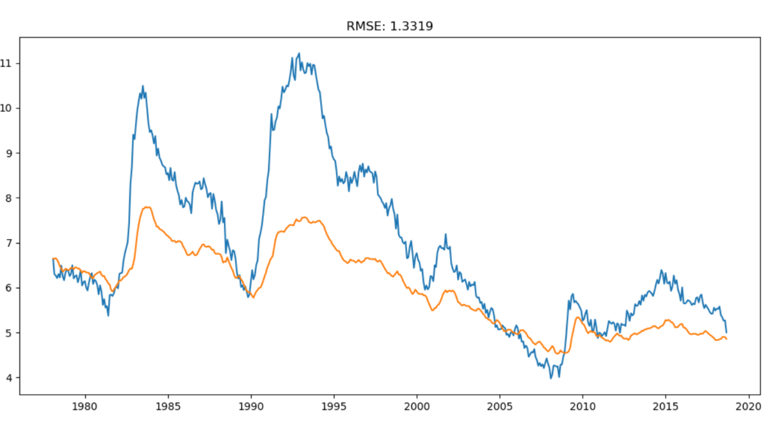

We see that the value of RMSE is 1.3319 this shows that the predictions are quite accurate, and our model is good.